On Thursday, August 12, 2021, the City of Sundown Library hosted the Back-the-Blue/Back-to-School event at the Sundown ISD’s parking lot to introduce students to local law enforcement during the district’s meet-and-greet open house. The library also used the effort to distribute summer reading program prizes.
Game Warden Drew Spencer, Sundown Police Chief Carey James, and Sundown PD Officer Jody Guerra were in attendance to interact with twenty-five attendees of all ages. The inquisitive group of youngsters were able to peek into the official’s vehicles, as well as board the Texas State Parks and Wildlife boat.
The efforts of the Sundown Police Department continued as the sudden rains unleashed on the mobile library site! There was some water damage and quite a few drenched organizers, but the event was considered a success by library director, A’ndrea McAdams. “We are so grateful for the local efforts to provide multi-level educational opportunities to our families.”
The “Tails & Tales” reading program had thirty-six participants, who were each eligible to receive a back-to-school pack filled with a book, pencil, bookmarks, and a sweet treat. Those who completed the program—either virtually or traditionally—were eligible to receive grand prizes. Some of those prizes included Nerf products, Lego products, or even a Kindle. Programs and prizes were generously funded through the Dollar General Literacy Foundation.
While the community reading goal of 10,000 minutes was not achieved this year, McAdams hopes that the digital literacy campaign brought to the library through ALA’s “Libraries Transforming Communities” grant did help contribute to the 6,800 minutes of reading and that next year’s efforts will expand even further.

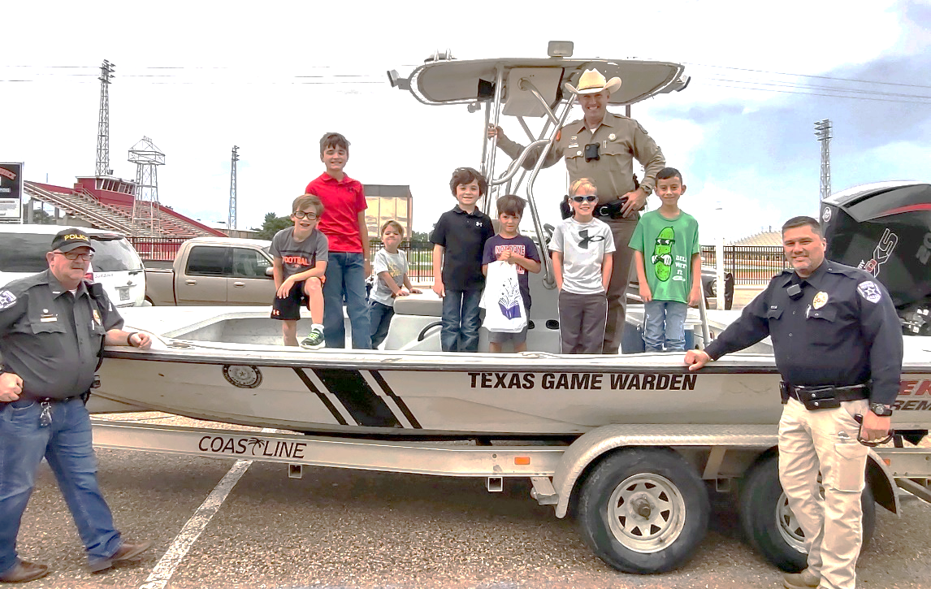
Figure 1 Law enforcement and local Sundown students. L-R Chief James, Game Warden Spencer, Officer Guerra.
Families represented: Buchanan, Lattimer, Strickland, & Stephens

